G.Arun

HTNO:2403A51291

Batch:12

CODES GENARATED BY GITHUB COPOILET:-

TASK1:-

Code:-

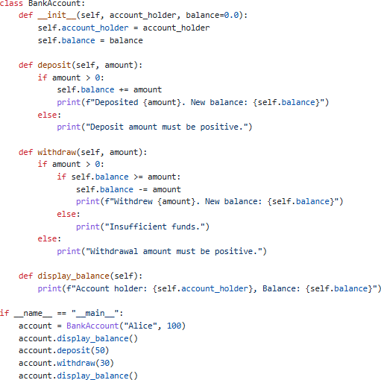

Output:-

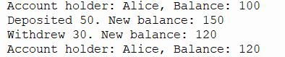

TASK 2:- CODE:-

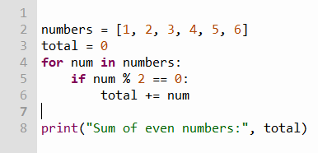

Output:-

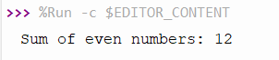

TASK 3:- CODE:-

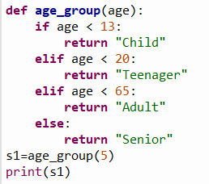

OUTPUT:-



TASK 4:- CODE:-

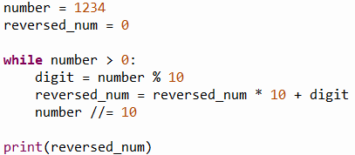

OUTPUT:-



TASK 5:-

Code:-

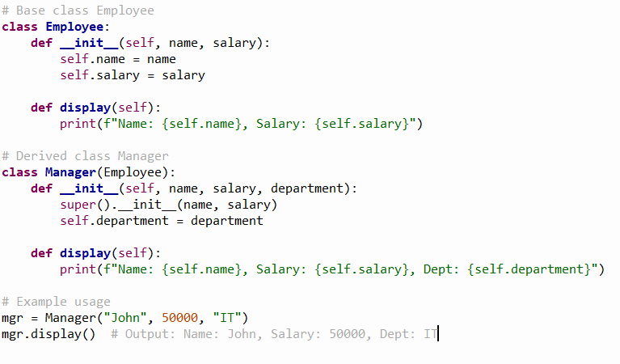

OUTPUT:-

